**Bipolar Junction Transistor Biasing Circuits and Bias Point Stability**

**ECE 2200L**

**Lab 7 Report**

**Abraham Nkum**

**Partner: Kevin Umana**

**Station # 24**

**March 5, 2020**

**Executive Summary:**

The DC characteristics of the BJT will be examined and how the different configurations impact the voltages and currents across the collector, emitter, and base. Students will calculate the voltages and currents and compare them to the measured values, students will also utilize Spice to simulate the voltages and currents for the different configurations on Spice.

**Objective:**

This experiment will examine the BJT characteristics for three types of DC biasing circuit. The three circuits will also be analyzed for stability of the bias points.

**Procedure:**

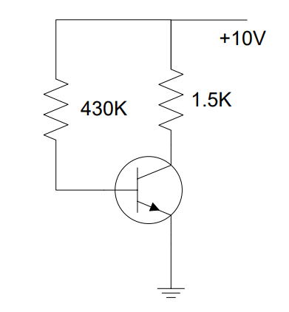

Figure 1 BJT Circuit Configuration 1

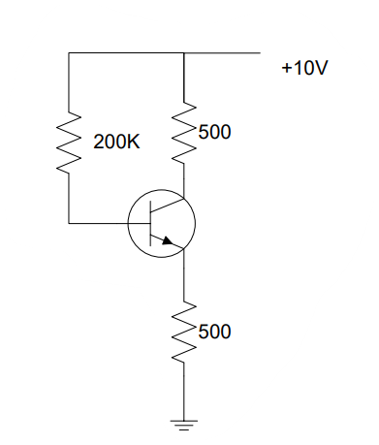

Figure 2 BJT Circuit Configuration 2

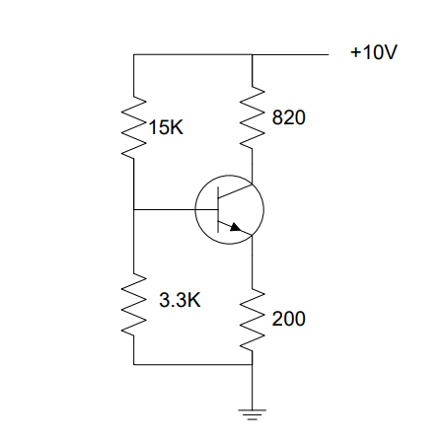

Figure 3 BJT Circuit Configuration 3

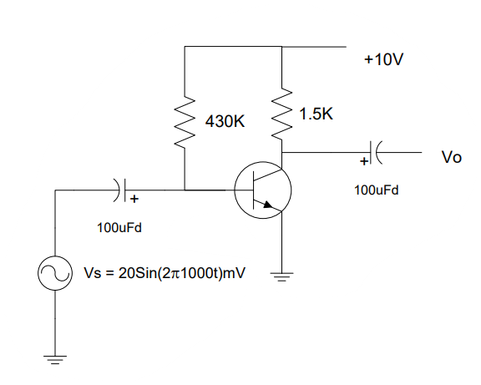

Figure 4 BJT Circuit Configuration 4

**Data:**

|  |  |  |  |  |  |  |
| --- | --- | --- | --- | --- | --- | --- |
|  | VC (V) | VB (V) | VE (V) | IB(µA) | IC(mA) | β |
| Calculated | 6.6 | 9.46 | 0.7 | 22 | 4.4 | 200 |
| Measured | 0.9069 | 0.6502 | 0.00114 | 21.72325581 | 6.041333333 | 278.1044142 |
| Difference % | 86.25% | 93.12% | 99.83% | 1.25% | 37.27 | 39% |

|  |  |  |  |  |  |  |
| --- | --- | --- | --- | --- | --- | --- |
|  | VC (V) | VB (V) | VE (V) | IB(µA) | IC(mA) | Β |
| Calculated | 3.1 | 6 | 3.1 | 30 | 6.2 | 200 |
| Measured | 3.65 | 5.615 | 3.67 | 28.075 | 7.3 | 260.0178094 |
| Difference % | 17.7% | 6.41% | 18.38% | 6.41% | 17.7% | 30% |

|  |  |  |  |  |  |  |
| --- | --- | --- | --- | --- | --- | --- |
|  | VC (V) | VB (V) | VE (V) | IB(µA) | IC(mA) | β |
| Calculated | 3.55 | 0.583 | 8.72 | 217 | 43.4 | 200 |
| Measured | 4.47 | 1.7402 | 1.1044 | 644.5185185 | 5.451219512 | 8.457816735 |
| Difference % | 25.91% | 198.491% | 689% | 196% | 87.44% | 95.77% |

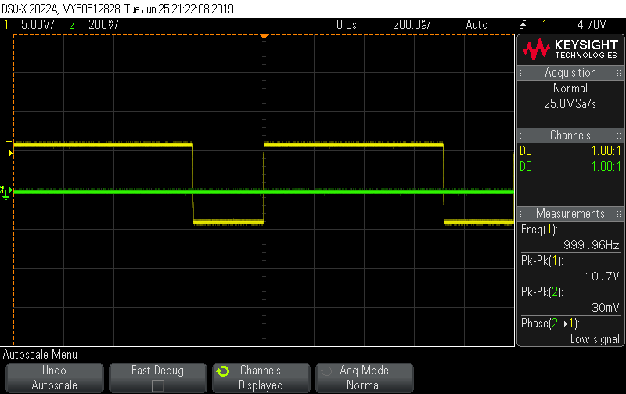

Figure 5 BJT Circuit Configuration 4 Oscilloscope Output

**Analysis:**

The first circuit configuration shown in Figure 1 is shown above, this circuit consists of a 430Ωk resistor connected to the base of the BJT and a 1.5kΩ resistor collected to the collector, both resistors are connected to a 10V power supply, the emitter is connected to ground. This configuration is called current biasing with a base-emitter voltage of 0.7 volts.

The second configuration is similar to the first configuration, however the resistor of the base was decreased to 200kΩ and the resistor of the collector was decreased to 500Ω. An additional 500Ω resistor was added to the emitter the other end of the resistor was set to ground. The configuration differs from the first one as the emitter resistance prevents the emitter voltage from being 0.7V. The current in the emitter changed as the current is about equal to the current through the collector.

The third configuration shown above in Figure 3 is the voltage divider biasing configuration. A 3.3kΩ resistor is connected from the base to ground and a 15kΩ is connected from base to a 10V power supply. An 820Ω resistor is connected from the collector to the 10V power supply and a 200Ω resistor is connected from the emitter to base. The two resistors connected to the base can be considered to in parallel creating 2.7kΩ resistance. The voltage supply is connected across the 3.3kΩ resistor and the voltage is measured the current is calculated by dividing the voltage across the parallel resistance of the 15kΩ resistor and the 3.3kΩ resistor.

For each of the three circuit configurations the voltages for the base, collector, and emitter were measured by placing a voltmeter across the resistor, the voltage of the emitter was measured by placing the voltmeter from the emitter pin and the other end to ground for Figure 1, for the other two configurations the voltage across the emitter was calculated by measuring the voltage across the resistor at the emitter.. The currents were measured by using the voltages measured across the resistors and dividing by the resistor values. The current across the emitter is about equal to the current across the collector.

The final circuit analyzed was the one shown in Figure 4 the circuit was constructed and the oscilloscope was set to measure the input and the output across the capacitor located at the collector. The screenshot of the oscilloscope is shown above in Figure 5, the screenshot shows a large peak-peak value for the input and a small peak-peak for the output.

**Discussion:**

The BJT used for this experiment was a 2N2222 transistor, the experiment called for two transistors with different beta values, however this was difficult to obtain and only one transistor was used. The prelab results were off from the calculated and measured results because the part QMMBT2222A was not available in the library and I wasn’t able to update the transistor to consist of the following parameters: β= 150, VAF = 40V, Is = 30e-15A. The measured and calculated values differ greatly a possible explanation for this discrepancy is the equations used to find the currents and voltages were wrong or the method used to obtain the values in lab were incorrect. The Spice simulation does not contain the same beta value as the one used in the lab so the values simulated in the prelab differ from both values. The resistors used have a different nominal value from the their actual value, however this difference does not account for the large percent differences.

**Prelab:**

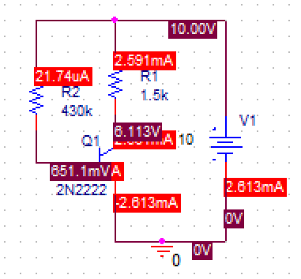

Figure 6 Spice Current and Voltage Simulation BJT Configuration 1

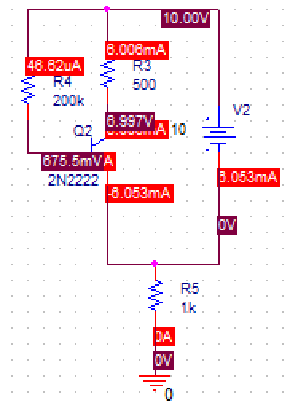

Figure 7 Spice Current and Voltage Simulation BJT Configuration 2

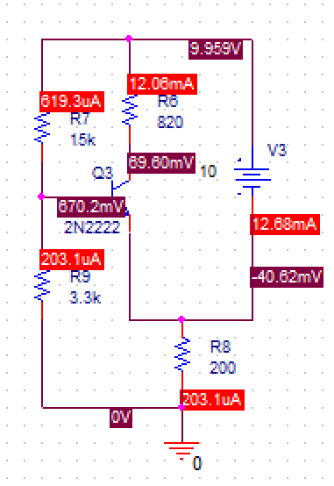

Figure 8 Spice Current and Voltage Simulation BJT Configuration 3